|  |  |
| --- | --- |
| **NAME** | APHRA INDA ANAK JAMES |
| **STUDENT NO.** | 05DIT24F1128 |

1. What HTML5 code is required to create a **hypertext reference** that links to a page at the location "**www.poliku.edu.my**. The underlined link on the page should be the text “**Politeknik Kuching Sarawak**”.

Answer:

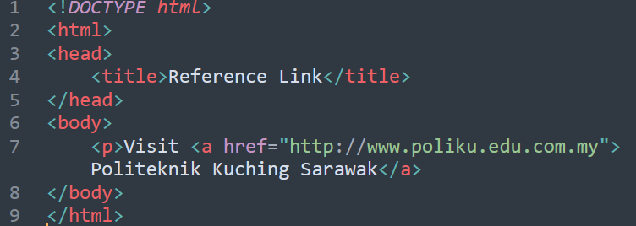

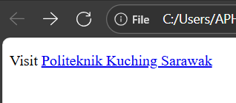

1. Write a simple HTML5 page with the title “**Simple CSS example**”. The body of the page should contain a **single paragraph** with the text “**Hello World**”. The text should have the “**color**” property set to “**Blue**”. An **internal style sheet** should be used to define an appropriate style that can be applied to the paragraph.

Answer:

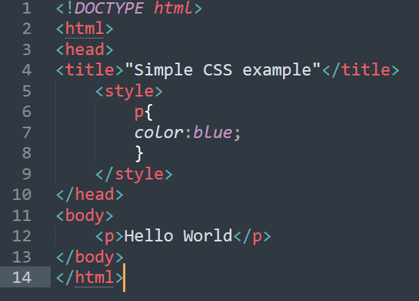

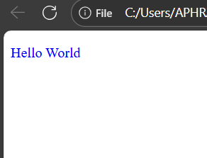

1. Use CSS to set the background color of the document (body) to yellow. Type your answer in the box

<!DOCTYPE html>

<html>

<head>

<style>

 

: yellow;



</style>

</head>

<body>

<h1>My Home Page</h1>

</body>

</html>

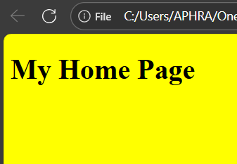

1. Write a simple HTML5 page with the title “**Fruit Colors**”.

The body of the page should contain a **single table** that lists three fruits and their colors.

Use an **internal style sheet** to style the table as follows:

* The table must have a **caption**: “Fruit Colors”.
* Use <thead> and <tbody> with proper <th> and <td>.
* Add scope="col" to column headers.
* Borders: **1px solid #333** on all cells, and border-collapse: collapse.
* Header cells (<th>) should have **background color: lightgray**.
* Table text should use the **font Arial, sans-serif**.

The table should have **two columns**: “Fruit” and “Color”, and **three rows** of data (e.g., Apple–Red, Banana–Yellow, Grape–Purple).

Answer:

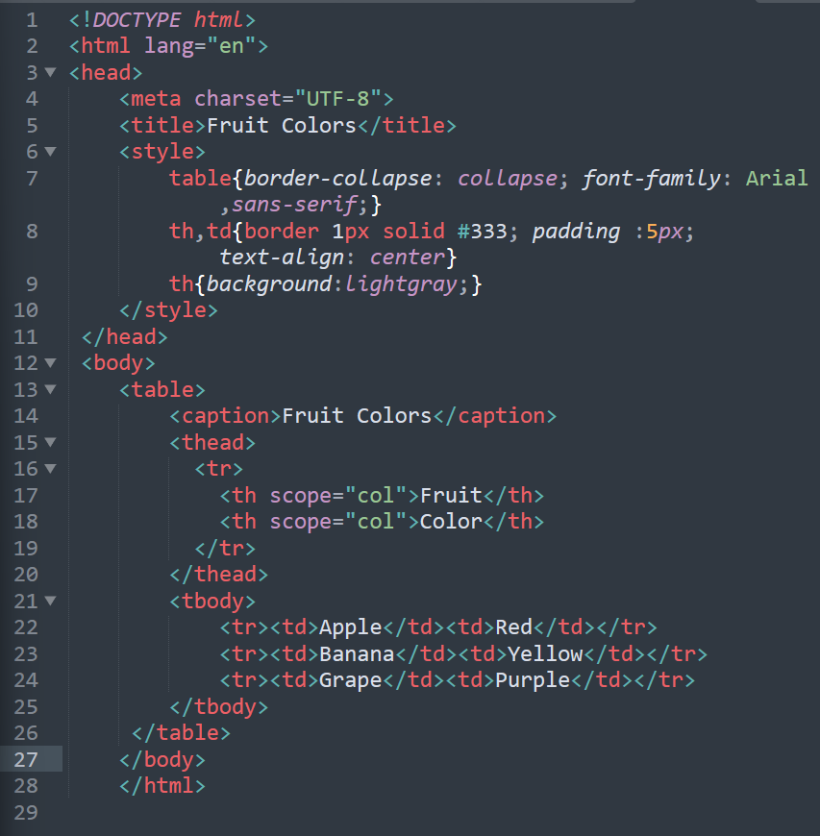

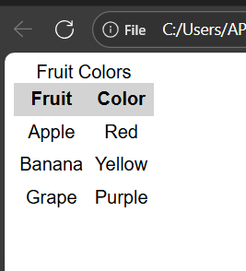

1. For instructions where the **order matters** (e.g., installation steps), which list type is most semantically appropriate?

A. <ul>  
B. <ol>  
C. <dl>  
D. Multiple <p> elements

Answer: B